Sensory Diets

Before reading this, find out a bit more about Sensory Processing Disorder by watching this video.

Just like a healthy diet, a child with sensory processing difficulties may need help to get a balance of sensory input throughout the day. Often, providing a child with sensory experiences at regular intervals helps them to regulate their arousal/ alertness levels and respond appropriately on a physical, emotional and behavioural level.

Children need to be at the optimum level of arousal in order to learn and a sensory diet includes a combination of activities to help them get there. Sensory diets are most effective when done at regular intervals throughout the day and not when the child is already in a heightened state. Many of these activities can be easily fitted into the child’s day or done with a whole group of children.

How to plan a sensory diet:

- Observe the child - note their behaviour at different times of day. Are they particularly ‘on the go’ at certain times? Are they very lethargic at other times? You will most likely begin to see a pattern emerge.
- Try out some of the activities listed below. Note which ones the child likes and how they change their behaviour. Do the activities calm them or alert them?
- Note which activities are calming for the child and which are alerting.
- Make a plan or timetable for the day, if you noted that the child was very lethargic at a certain time, plan a stimulating activity before that. If they are particularly energetic at a certain time, plan a calming activity before you expect them to do anything which requires a greater level of focus.

Heavy work activities:

Heavy work activities are those which involve heavy input through the muscles. These are your go to activities for children with sensory processing difficulties. They can be calming or alerting depending on the child.

Try the following activities with the child, note whether they liked them or disliked them and whether the activity calms or alerts them:

Activity: | Comment:  Did they like it (Y/N)?  Was it alerting or calming (A/C)? | Incorporating this into the daily routine:
Carrying or moving heavy items  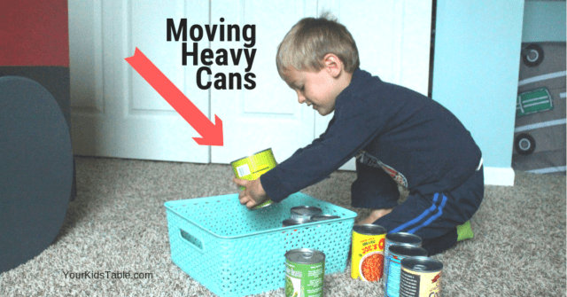 |  | - Tidying up heavier items at tidy up time  - Carrying boxes to do jobs - e.g. carrying a box of milk to the snack table  - Wearing a backpack with something heavy in it (such as a catalogue)  - Carrying bags of shopping  - Lifting heavy tyres outside
Pushing or pulling heavy items  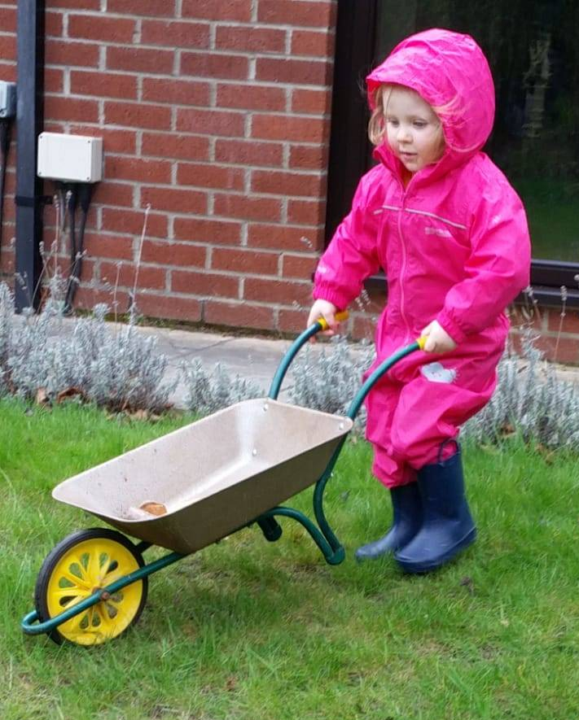 |  | - Pushing a wheelbarrow filled with heavy items  - Playing tug of war  - Pushing their friend on a bike  - Help adults by pushing and holding open heavy doors  - Lying on a scooter board on their tummy and pushing themselves with their hands
Digging and mixing activities  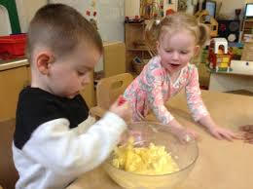 |  | - Digging or raking in the garden  - Mixing cake or bread mixture (mixture that is difficult to mix is best)  - Whisking bubbles in a bowl
Jumping and climbing activities  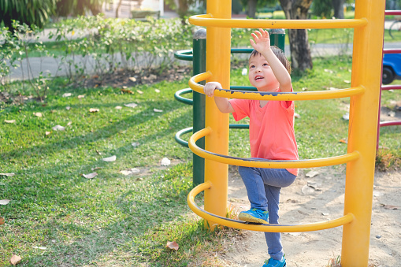 |  | - Jumping on a trampoline or trampette  - Obstacle courses  - Jumping and clapping at the same time  - Climbing on the climbing frame or gym equipment  - Bouncing on a therapy ball
Deep pressure activities  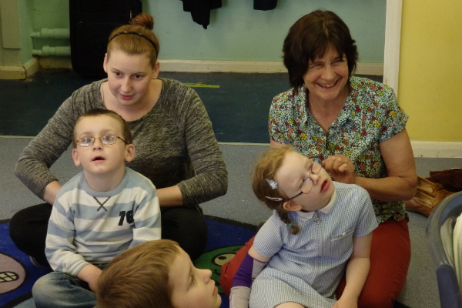 |  | - Roll the child up tight in a blanket  - Firm massage with hands or with brushes  - ‘Squish’ the child between 2 big cushions  - Bear hugs  - Wearing a weighted vest  - Sitting with a heavy cushion on their lap
Activities using their hands  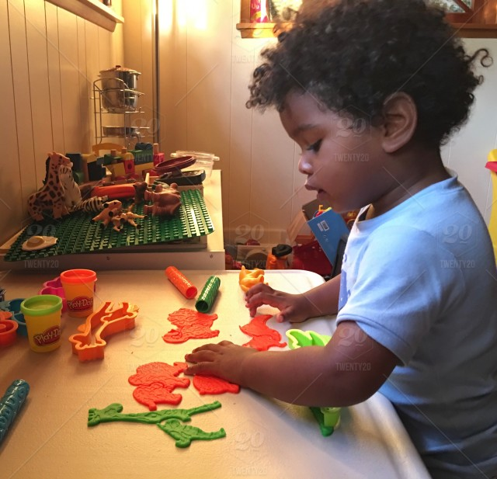 |  | - Use spray bottles to spray tables and wipe with a cloth  - Squeezing stress balls, theraputty or playdough  - Using tweezers to pick up small items  - Popping bubble wrap with thumb and fingers
Chewing and oral activities   |  | - Chewing a chewy tube  - Eating crunchy or chewy food at snack time, like carrot sticks or dried apricots  - Sucking through straws - especially thick liquids like smoothies  - Using an electric toothbrush - both on their teeth but also their cheeks and jaw  - Blowing bubbles through a straw
Swinging or rocking activities   |  | - Swinging on a swing  - Swinging in a hammock  - Sitting on a rocking chair  - Lying over a peanut ball and rolling forwards and backwards

Example timetable:

 | Monday | Tuesday | Wednesday | Thursday | Friday
Morning

Lunch time

Afternoon

