Nursery Facility for Rent – St Paul’s Catholic Primary School, Alnwick
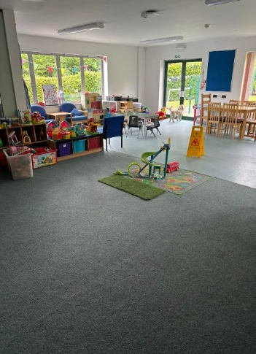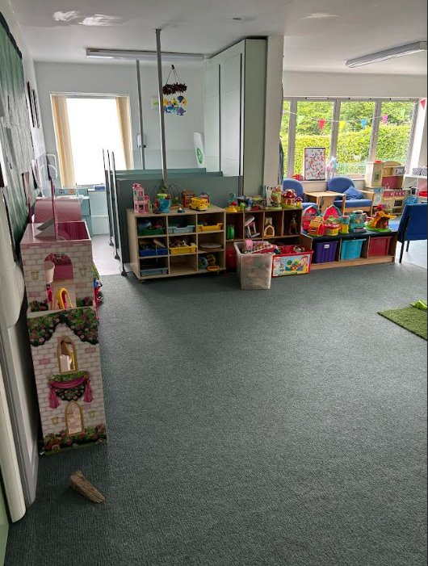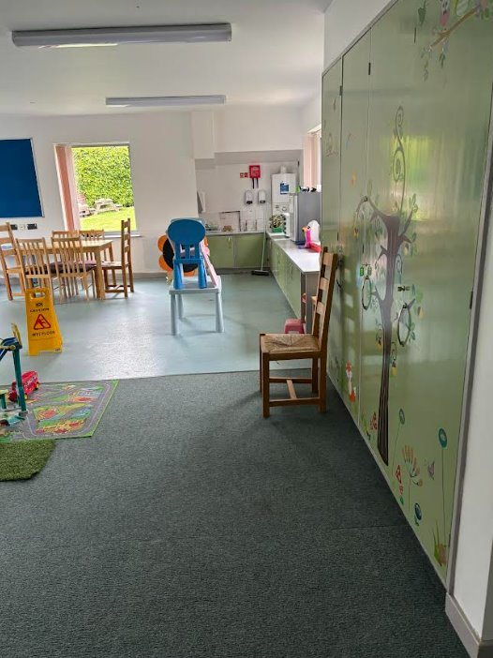
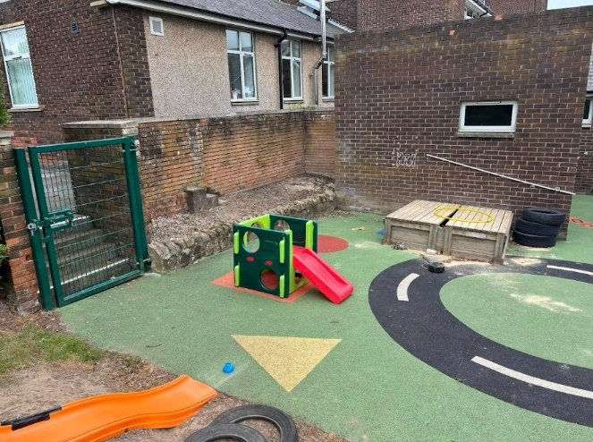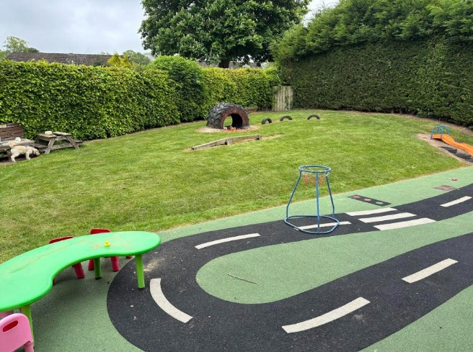

A fantastic opportunity to lease a fully equipped nursery facility within St Paul’s Catholic Primary School in Alnwick – part of the Bishop Bewick Education Trust, situated in the expanding historic market town of Alnwick. Please look at our school’s extensive facilities and provision offer at www.stpaulsalnwick.co.uk
This self-contained space is perfect for an established or aspiring early years provider ready to make a difference in the community.
Key Features:
Layout includes a large main playroom, a second room, kitchen, toilets, and manager’s office.
CLASSROOM 1: Large open space – half wet flooring / half carpet. Refurbished to meet requirements and needs of two year olds with appropriate sized bathroom facilities and changing unit. The classroom has large built in storage cupboards and units, inclusive of a sink and drying area. It has large windows and double doors, allowing lots of light into the room and with immediate access to the soft surface outdoor space and grassed garden area. A new boiler was fitted in 2025.
CLASSROOM 2: Large open space – all carpet.​ Secure kitchen area with breakfast bar.​ Kitchen has full sized cooker with oven, two sinks, dishwasher, fridge and built in storage units.
CORRIDOR 1: Links both classrooms. Has access to both private car park and secure play area at each end. A large cupboard in the corridor holds a washing machine. Cloakroom pegs offer hanging space. There are two adult toilets – both with disabled access. One with fold down baby change facility.​
CORRIDOR 2:​ Cloakroom area that could be turned into a staff area for breaks/PPA/ office etc. Large electric shutter cupboard for storage​.
OUTSIDE SPACE: Secure access and sole use of well-developed outdoor play area with fencing. Area has large grassed and soft surface area. There is a flower bed/veg patch. The area has some fitted play equipment – sand pit / slide / tyre climb/mud kitchen
There is a large self-contained brick storage building with external access and locking door.
Private car parking with twenty-five marked spaces. Secure, lockable gates.
Choice of two entrances/exits to building – one from Springfield Road and from school site.
Rent to be discussed directly with interested parties.
Ideal for:
An established or aspiring childcare provider committed to quality and community impact, looking for an opportunity to establish a successful provision in a beautiful location.
Viewings Welcome
Interested providers are warmly invited to arrange a site visit to discuss this opportunity further.
Contact:
Eileen Lomax – Headteacher
St. Paul’s Catholic Primary School
South Road
Alnwick
Northumberland
NE66 2NU
Email: admin@stpaulsalnwick.co.uk
Phone: 01665 602547

