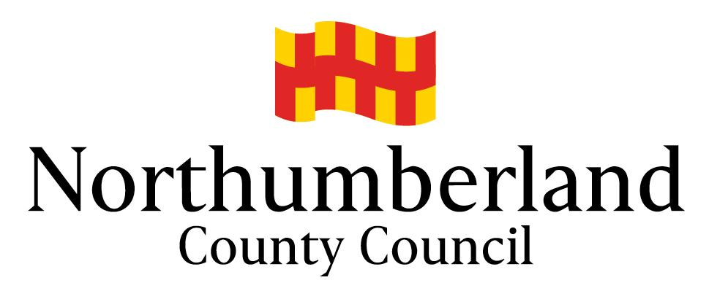

**Local Authority Staff Absence Teachers and Support Staff Insurance Supply Schemes from Sept 2025**

**Background**

Schools/Academies staff absence insurance schemes from 1 September 2025.

**Making a Claim**

The 2025/26 Claim Form for the Teachers Scheme “the pink one”

The 2025/26 Claim Form for the Support Staff Scheme “the yellow one”

Claim forms should be submitted promptly following the end of each month, please ensure forms are fully completed to ensure that claims can be processed, and all due payments made efficiently.

Claims can only be processed for Term Time only and to be approved by the Headteacher/Business Manager.

**No claims that are received more than 2 months after the end of a period will be paid.**

Insert your 4 digit School Number preceded by **two zeros “00”** in the “School No” box. This will prepopulate the School Name and Level of Cover. Complete the rest of the form fully, using the drop down menus for the “Post” and “Reason for Absence” fields. Please ensure you complete the final column, which records the date the absence commenced, which may fall in a preceding period, not necessarily in that month for which a claim is being made. Schools are reminded that the maximum period for which a claim can be made is 12 months.

**Rates of Benefit Payment**

The Teachers Scheme will pay benefits based on a rate of £28.09 per hour, up to a maximum of 32.5 hours per week, which represents 1 fte, for the purposes of the Scheme. Part Time staff are paid on a pro rata basis.

The Support Staff Scheme will pay benefits based on a rate of £12.69 per hour, up to a maximum of 37 hours per week, which represents 1 fte, for the purposes of the Scheme. Part Time staff are paid on a pro rata basis.

For further information please use the dedicated email address: [insurance.supply@northumberland.gov.uk](mailto:insurance.supply@northumberland.gov.uk)

**Bruce Parvin**

**Education and Skills Business Manager**  **1 September 2025**